все 5 галочек (на моменте с выбором)
https://code.visualstudio.com/download

7.2.16+
https://www.oracle.com/virtualization/technologies/vm/downloads/virtualbox-downloads.html

Ubuntu Server 26.04.1 LTS
https://ubuntu.com/download/server

3.70.6+
https://filezilla.ru/get/

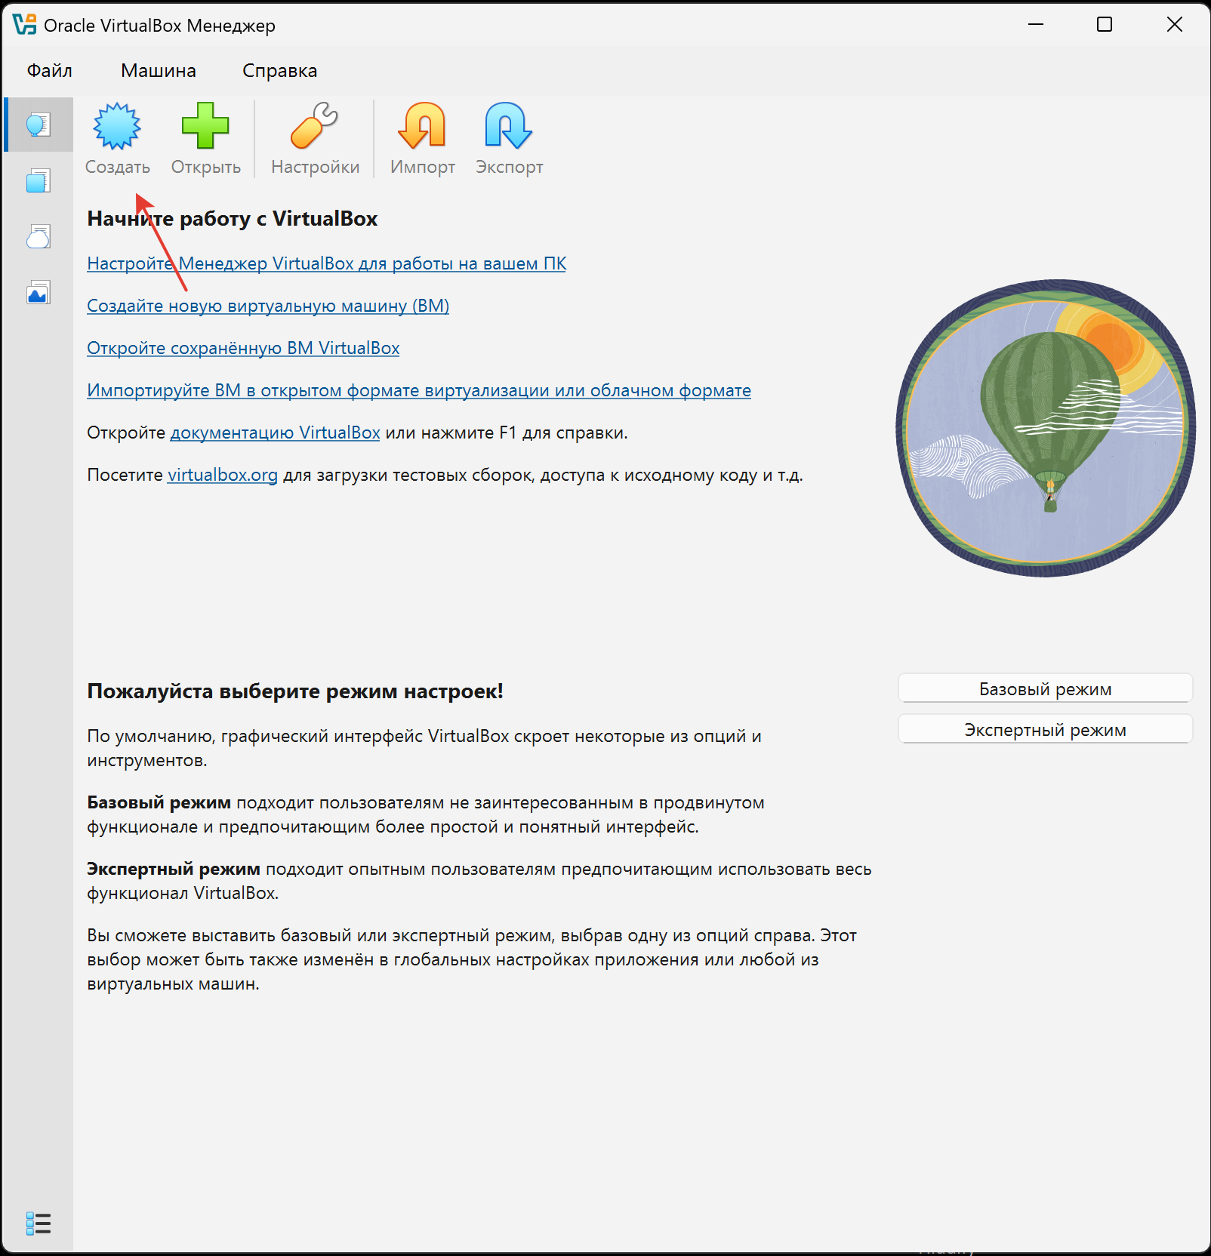
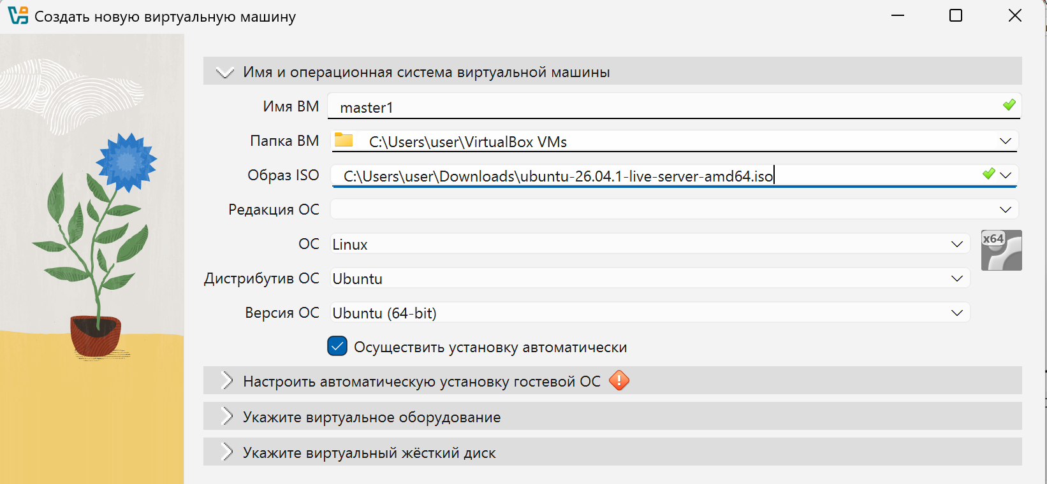
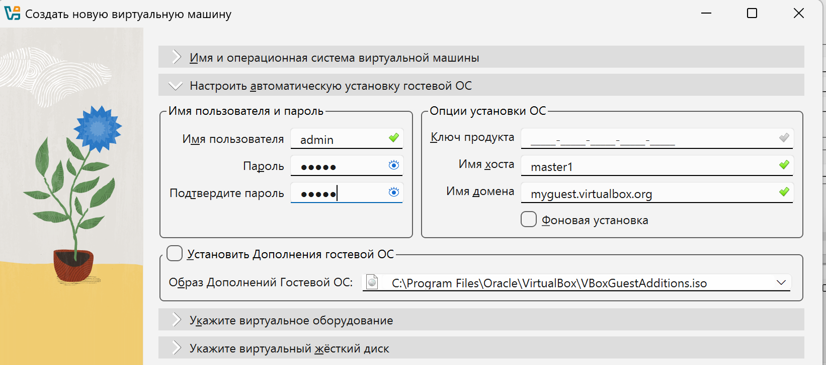
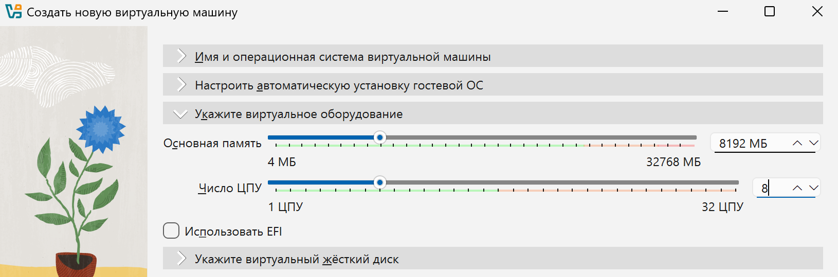
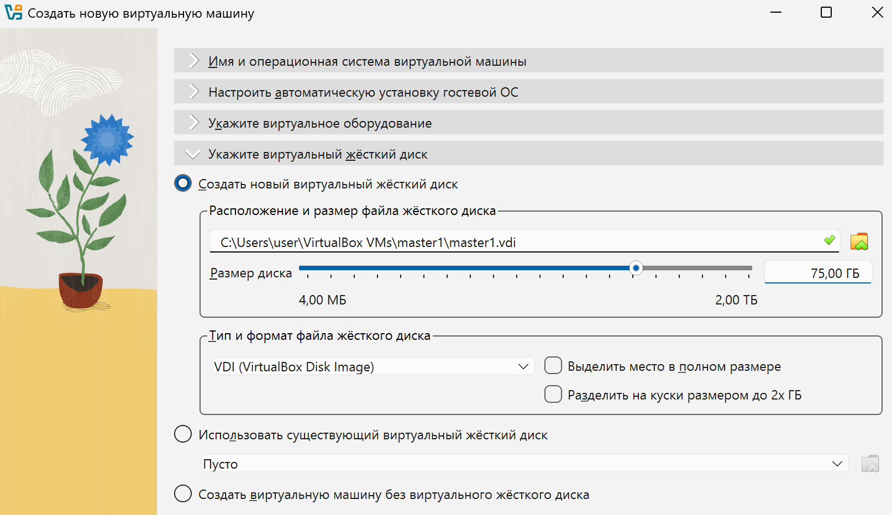

sudo apt update && sudo apt upgrade
sudo apt install openssh-server
ip a

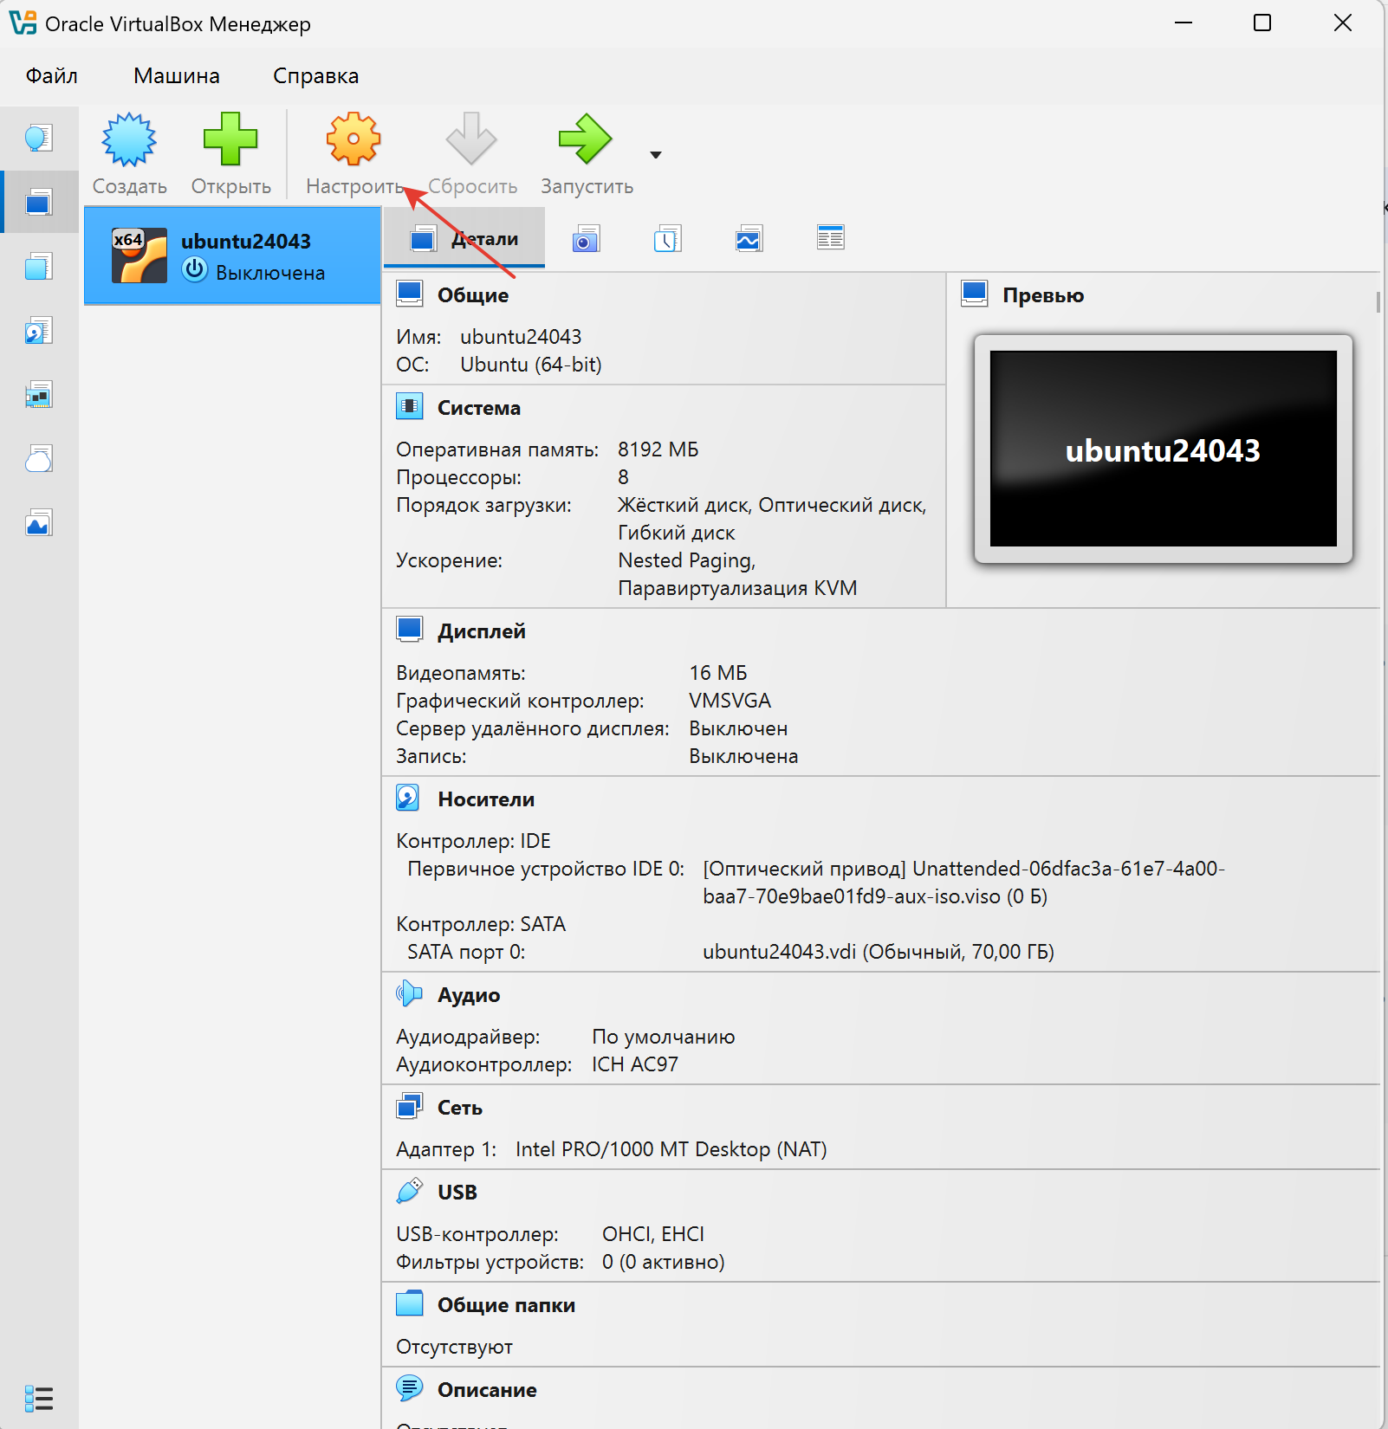
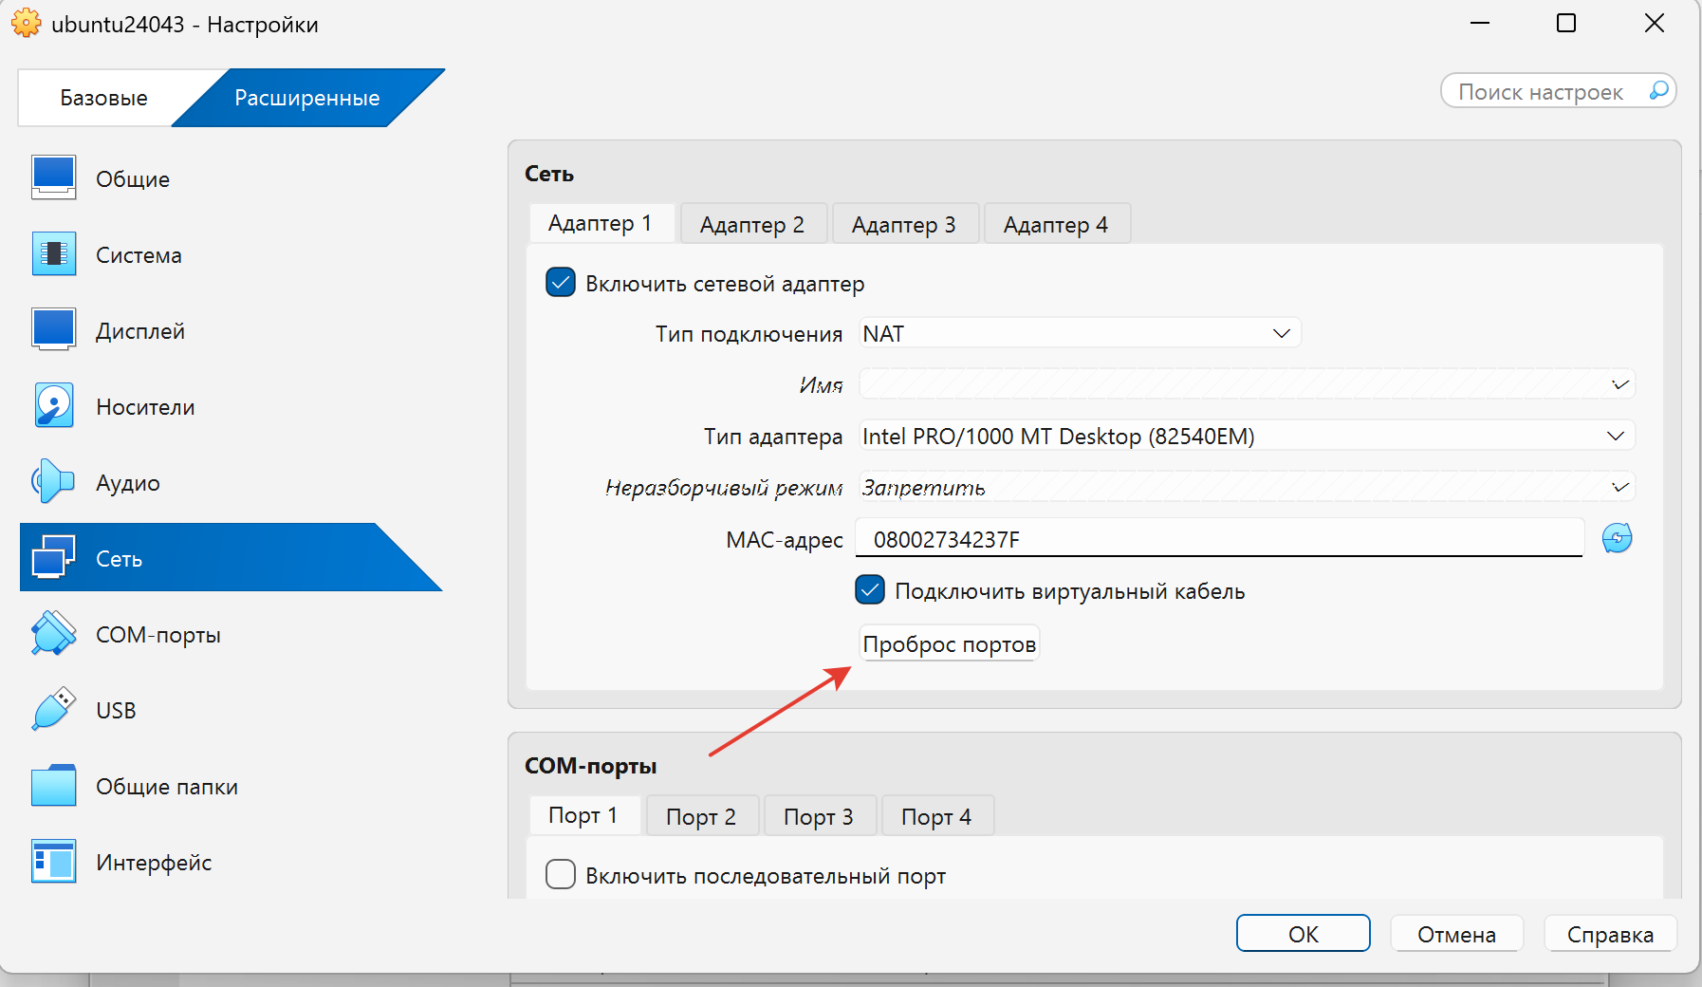
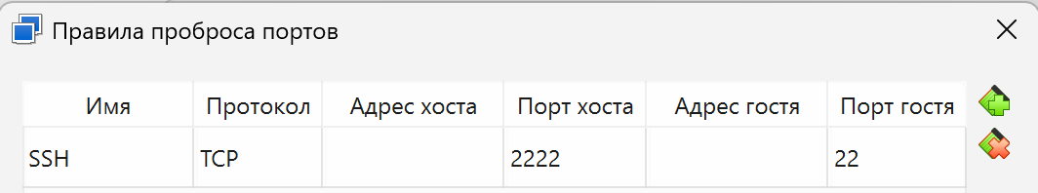
sudo systemctl status ssh
sudo systemctl start ssh
sudo systemctl enable ssh
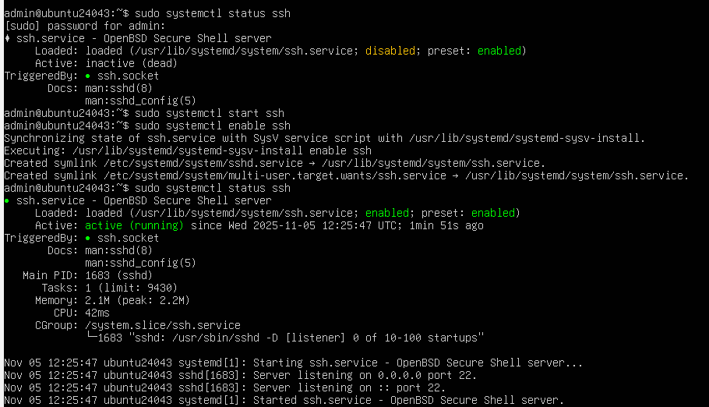
ssh admin@localhost -p 2222
(или ssh-keygen -R "[localhost]:2222")
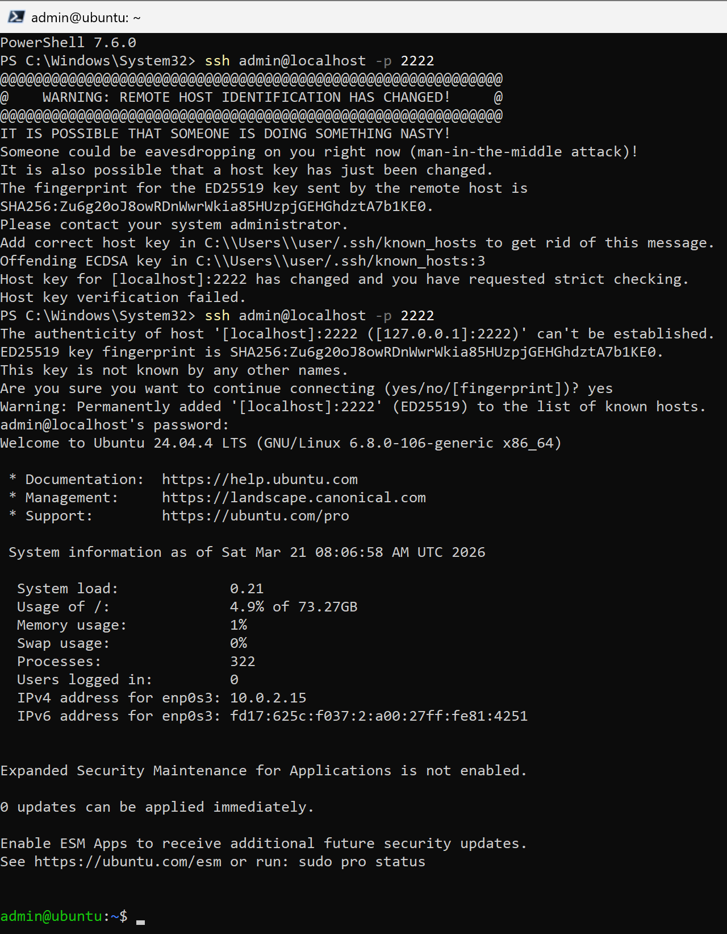
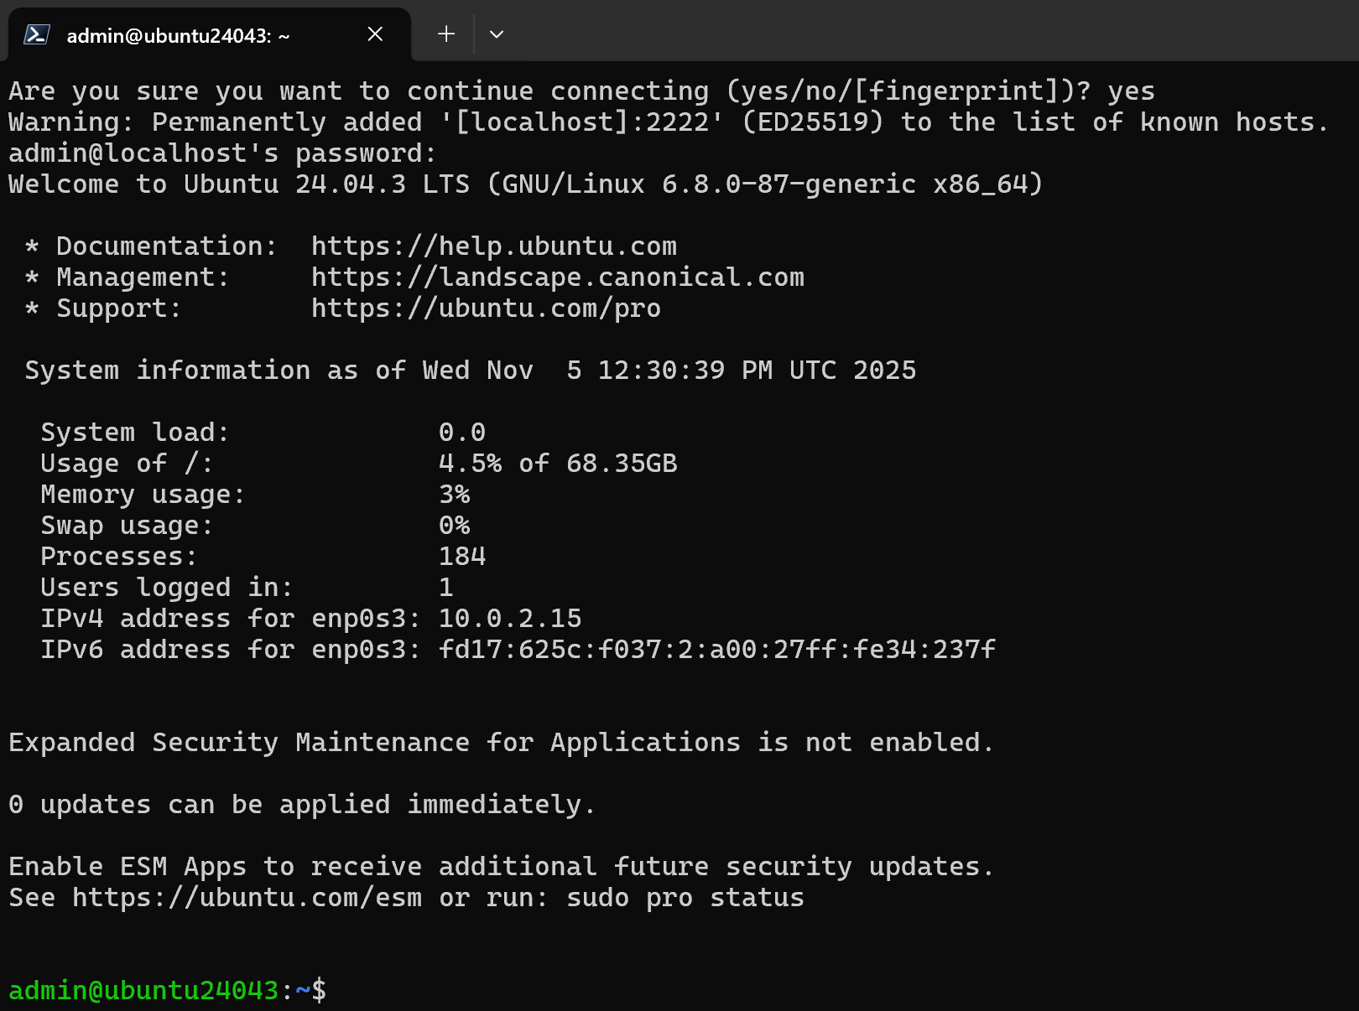
https://docs.docker.com/engine/install/ubuntu/#install-using-the-repository

sudo systemctl enable docker
sudo systemctl status docker
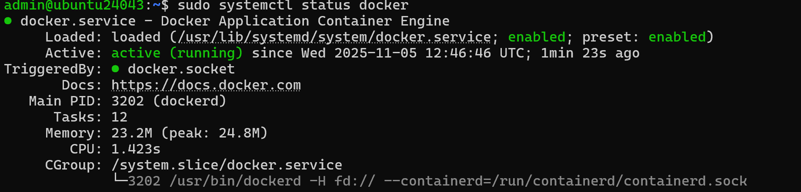
C:\Users\user\.ssh
Host ubuntu24043
HostName localhost
User admin
Port 2222
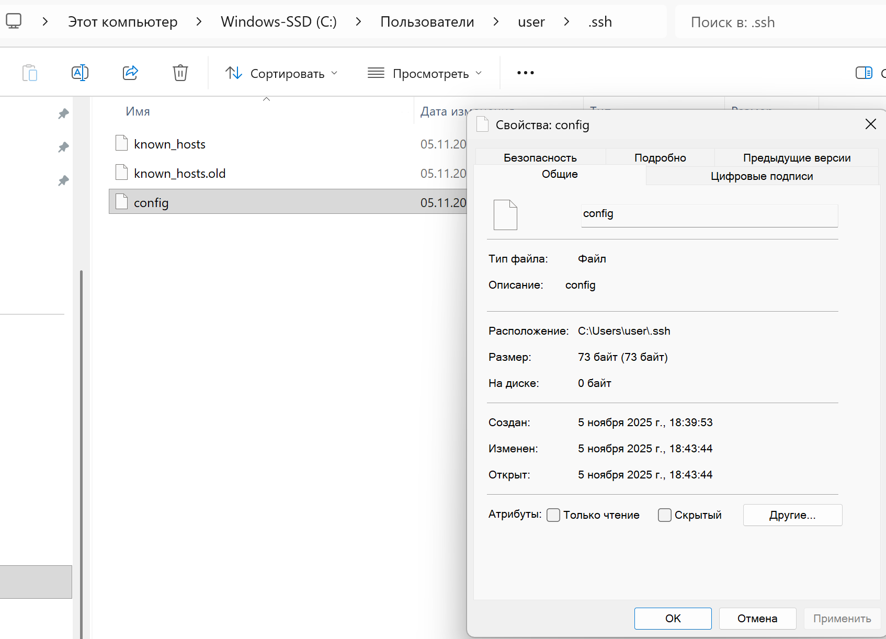

https://filezilla.ru/
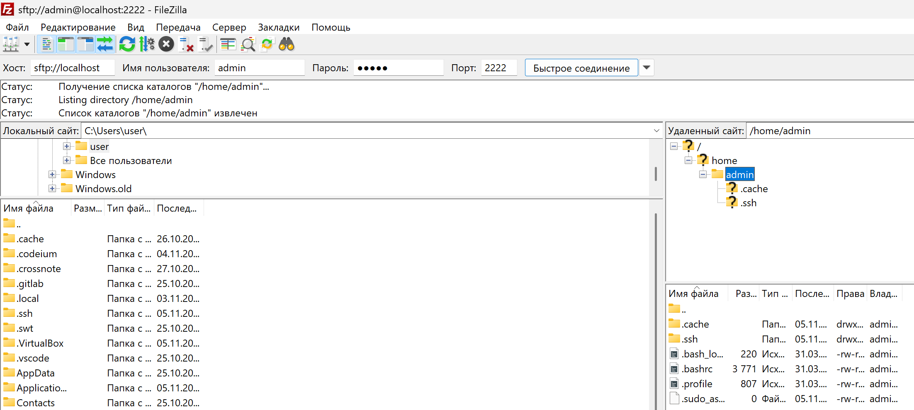
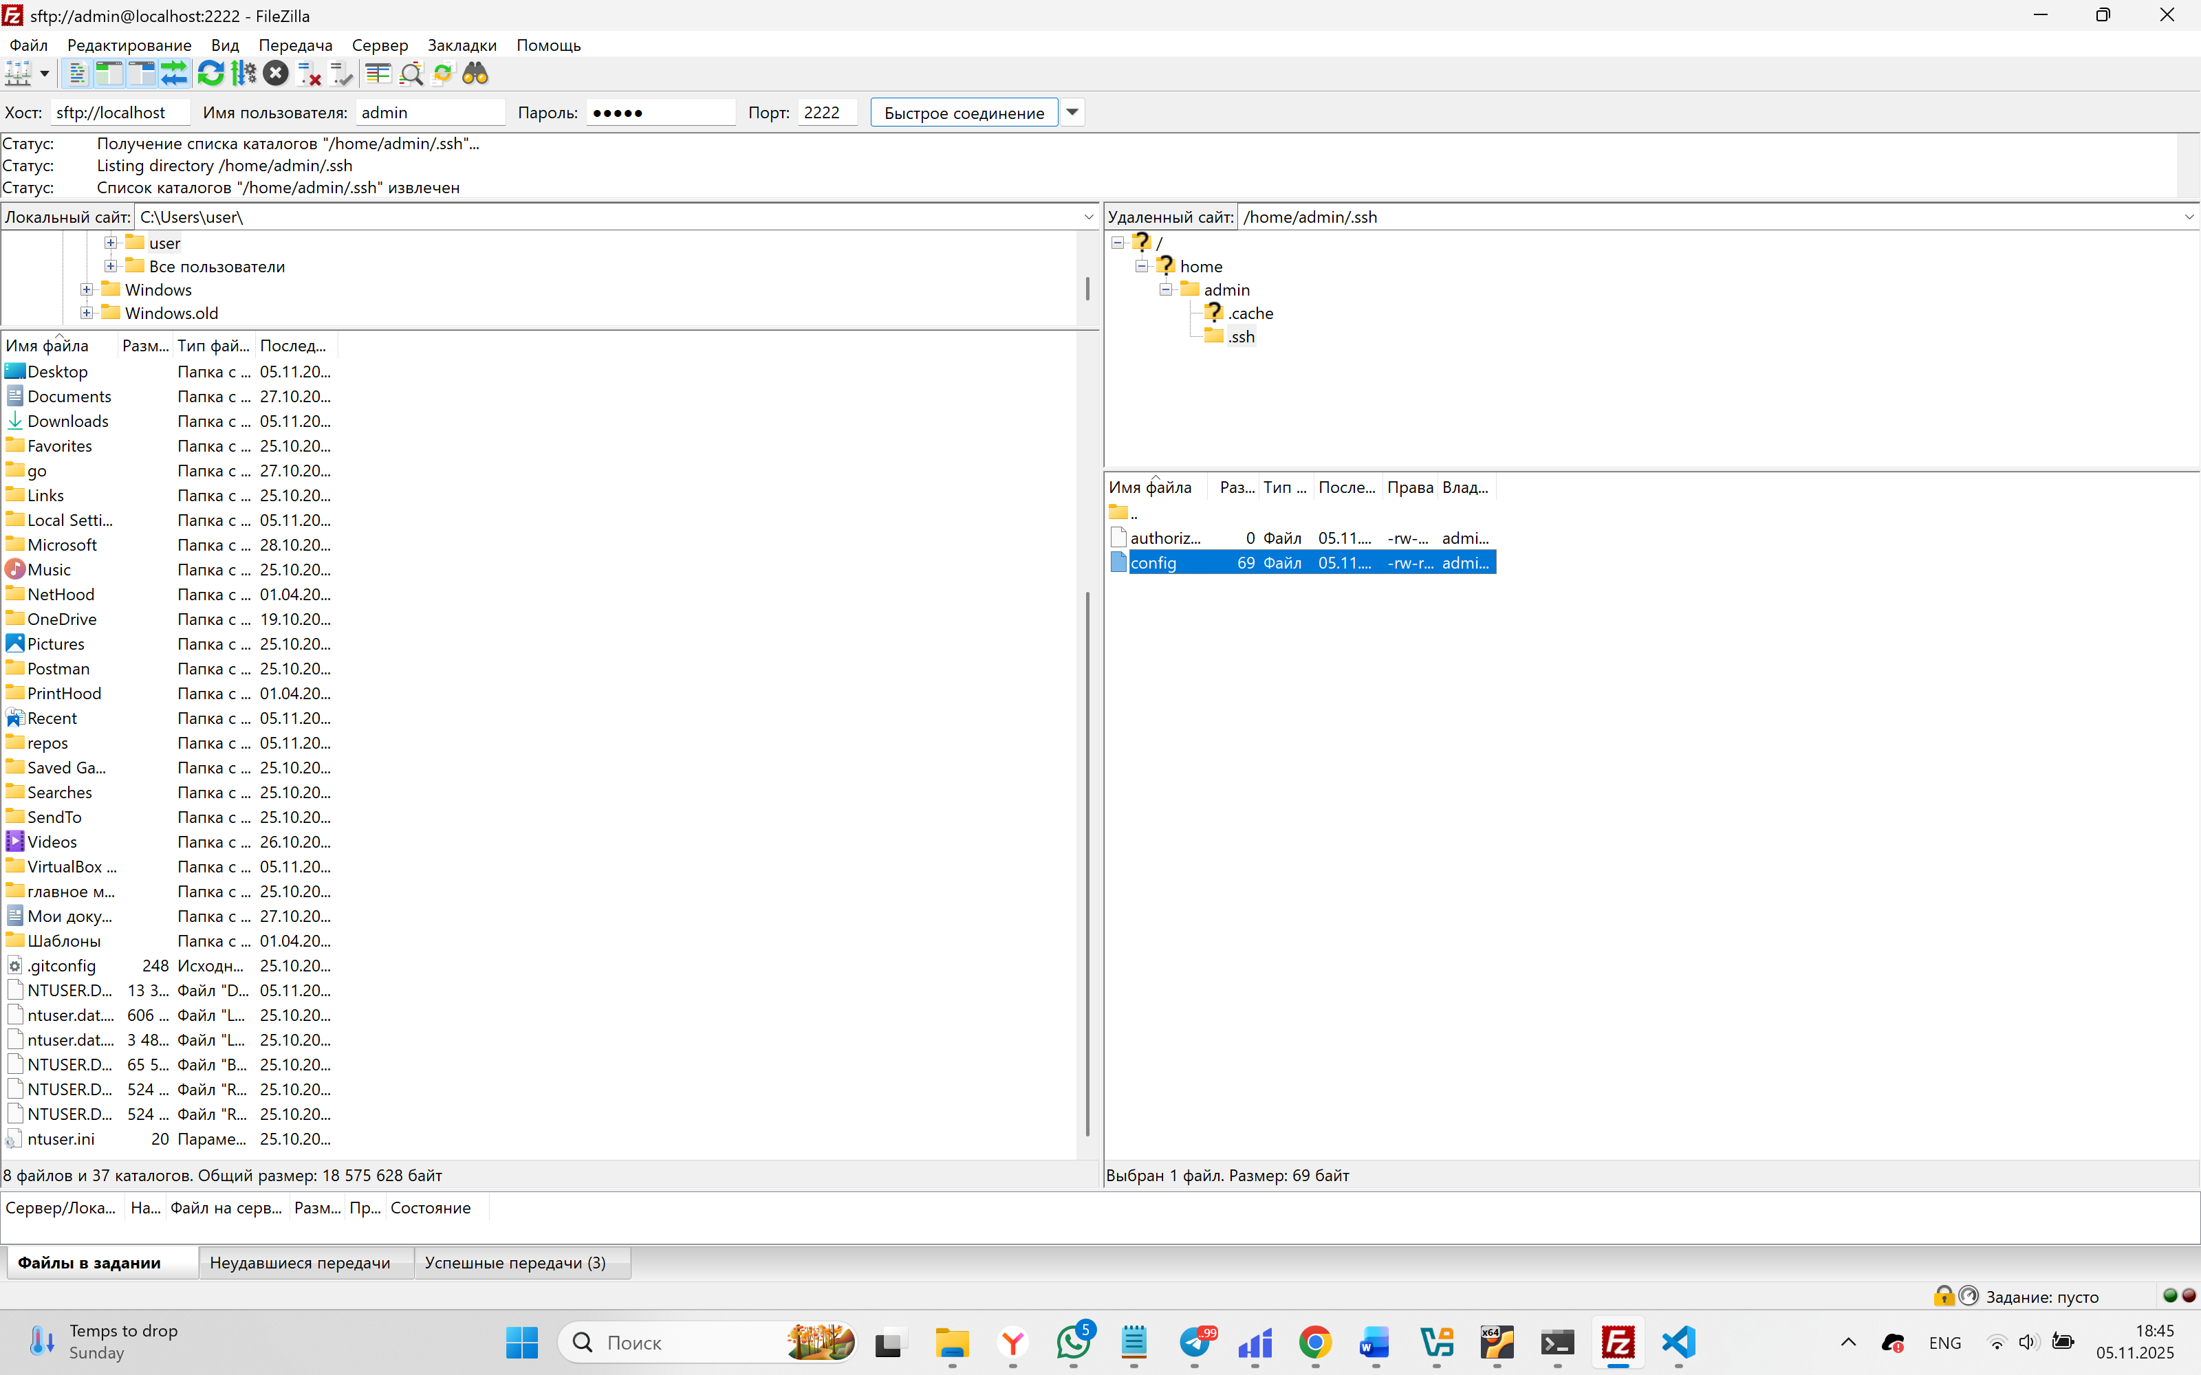
donjayamanne.python-extension-pack
ms-toolsai.jupyter
ms-vscode-remote.remote-ssh
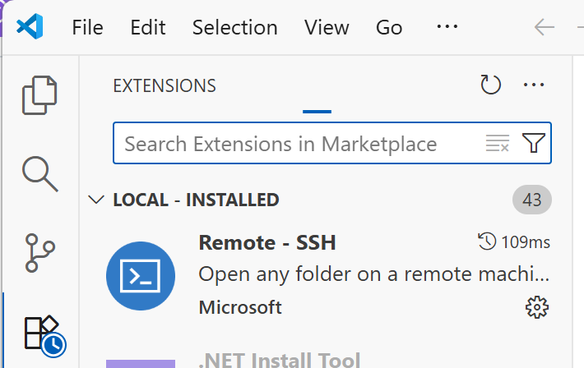
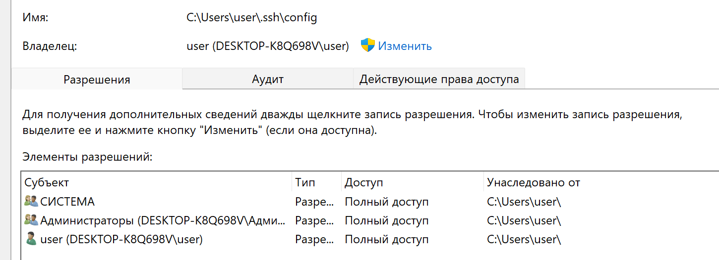 | 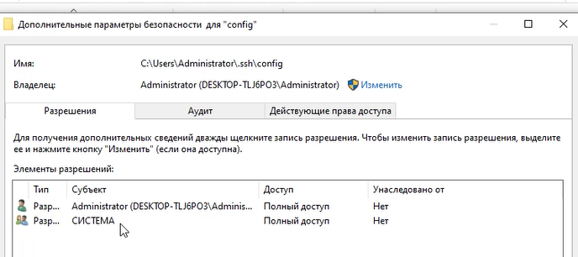

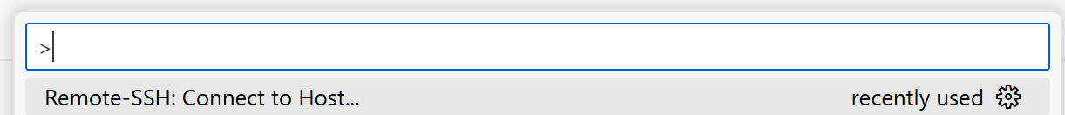
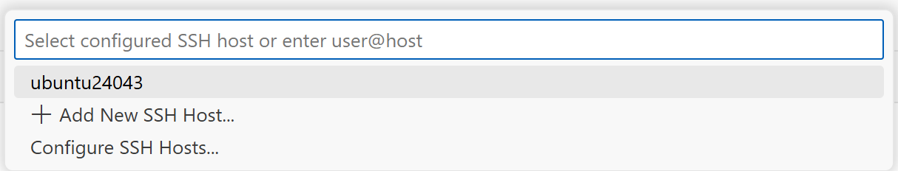
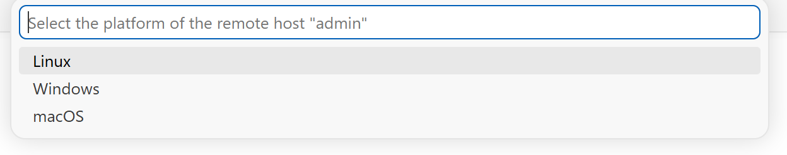
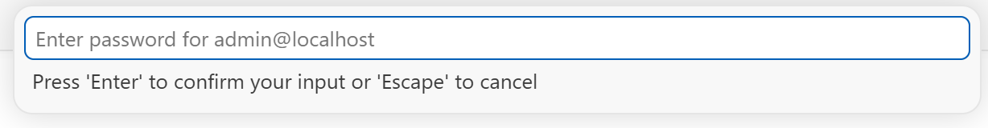
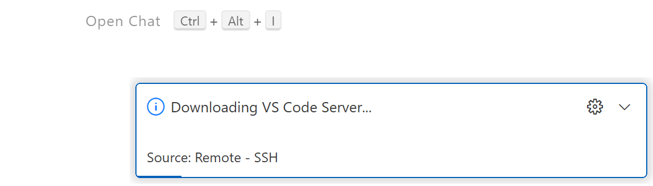
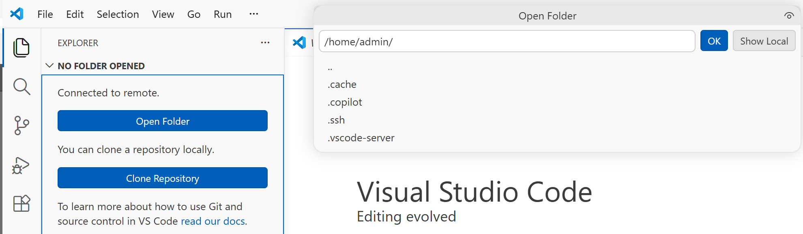
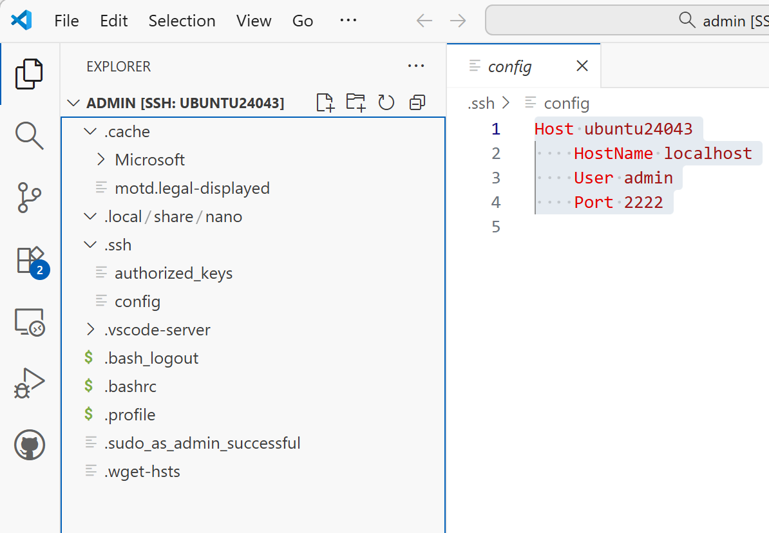
ssh-keygen -t ed25519 -C "vscode-local"
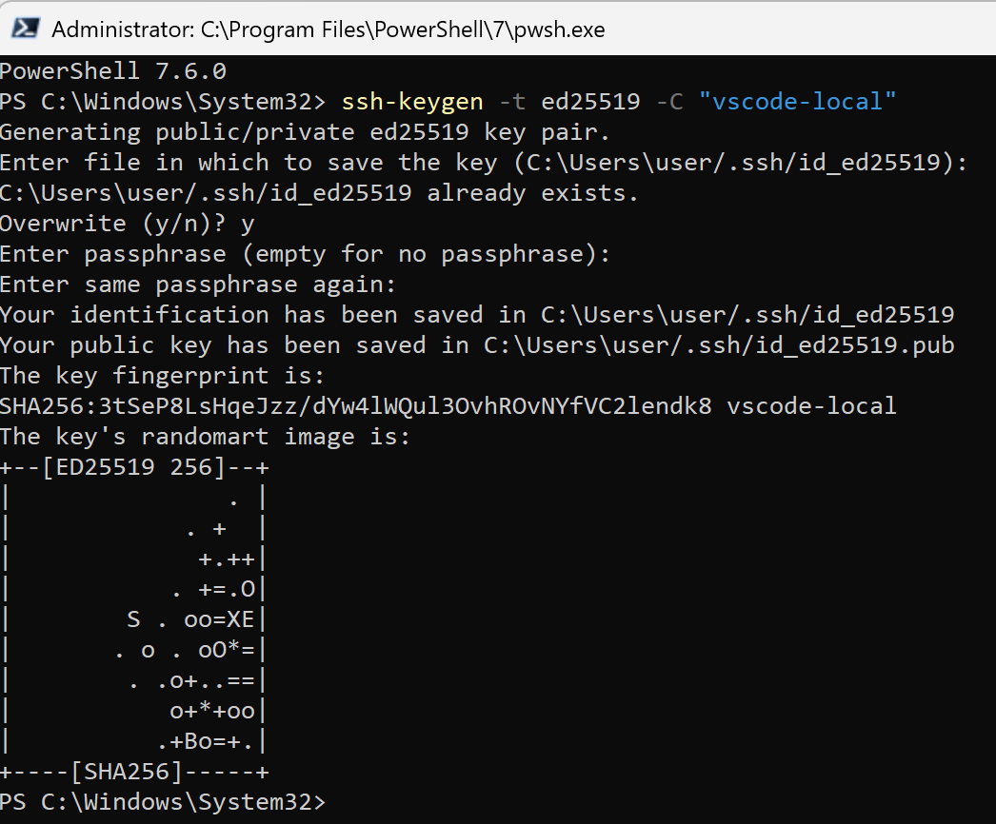 | 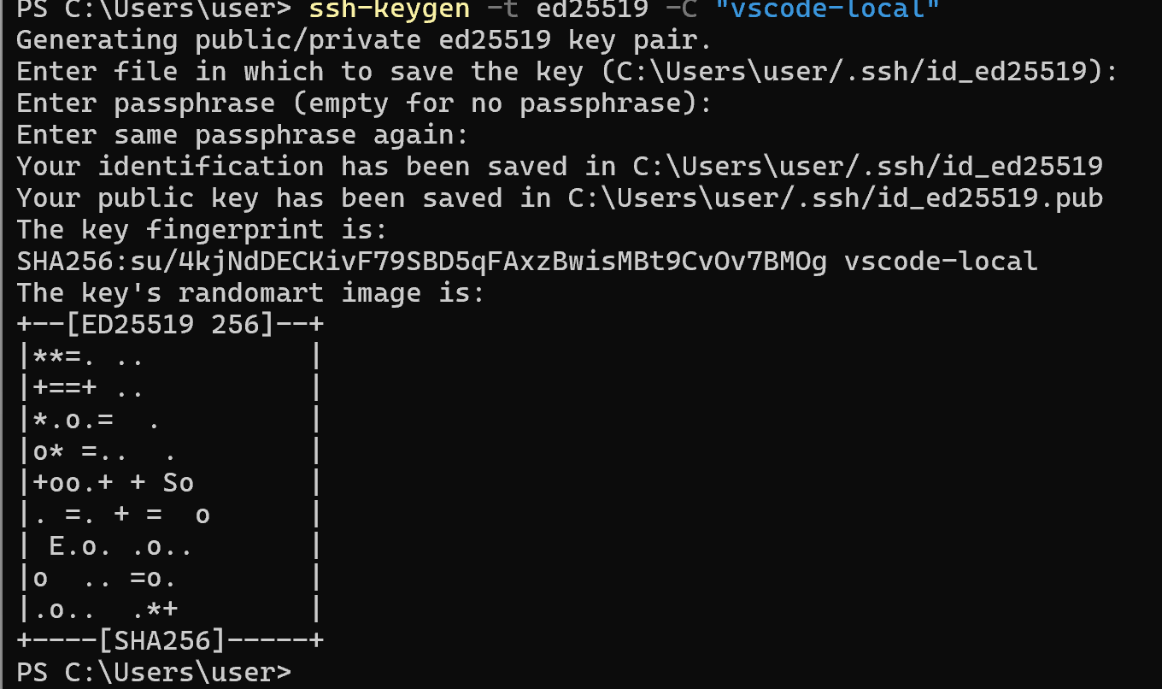

cat ~/.ssh/id_ed25519.pub
mkdir -p ~/.ssh
chmod 700 ~/.ssh
nano ~/.ssh/authorized_keys
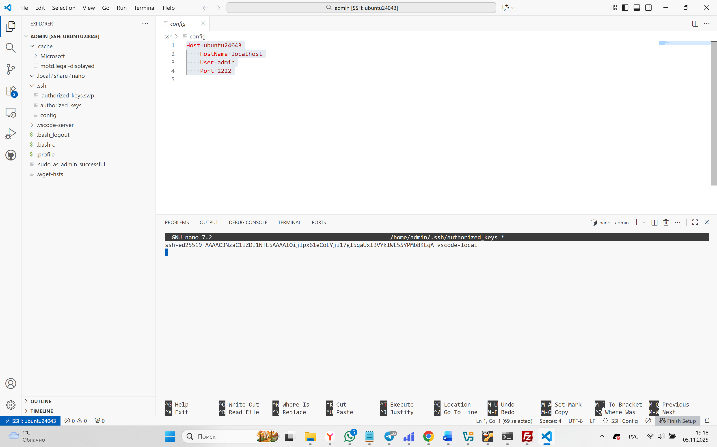
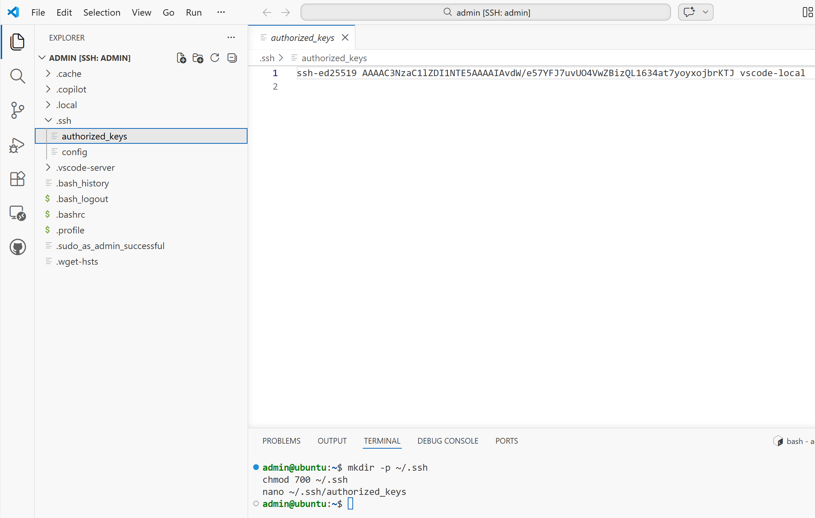
chmod 600 ~/.ssh/authorized_keys
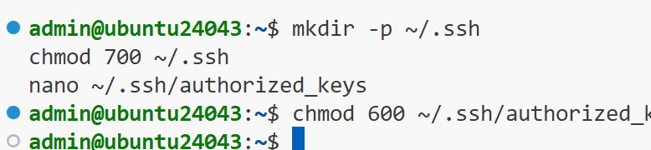

Host ubuntu_admin
HostName localhost
User admin
Port 2222

Host ubuntu_root
HostName localhost
User root
Port 2222

sudo nano /etc/ssh/sshd_config
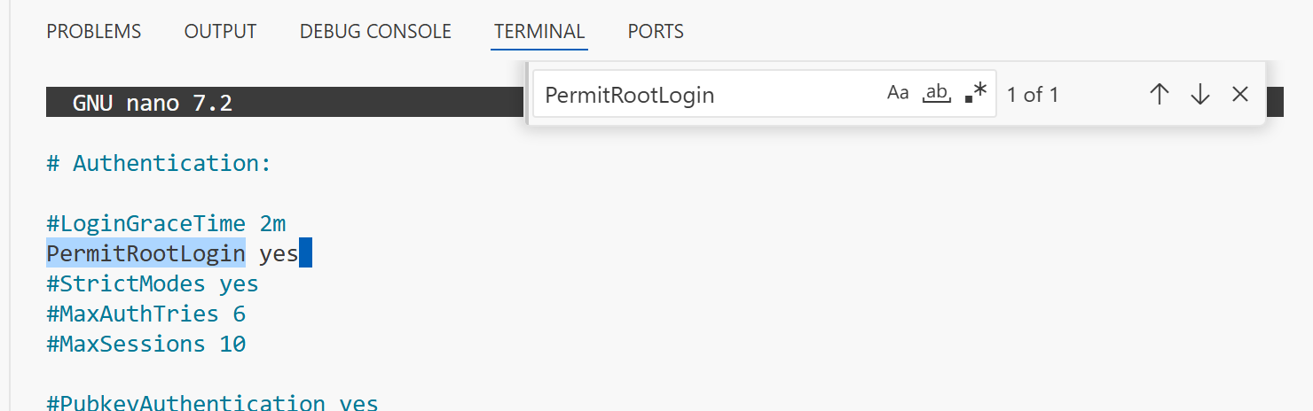
sudo passwd -u root
sudo passwd root
sudo systemctl restart ssh
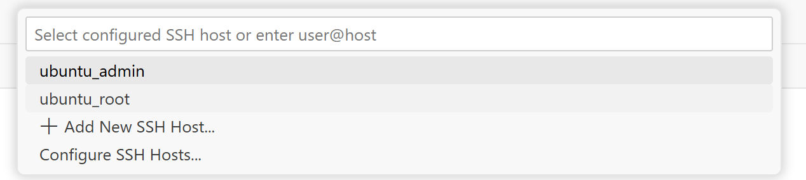
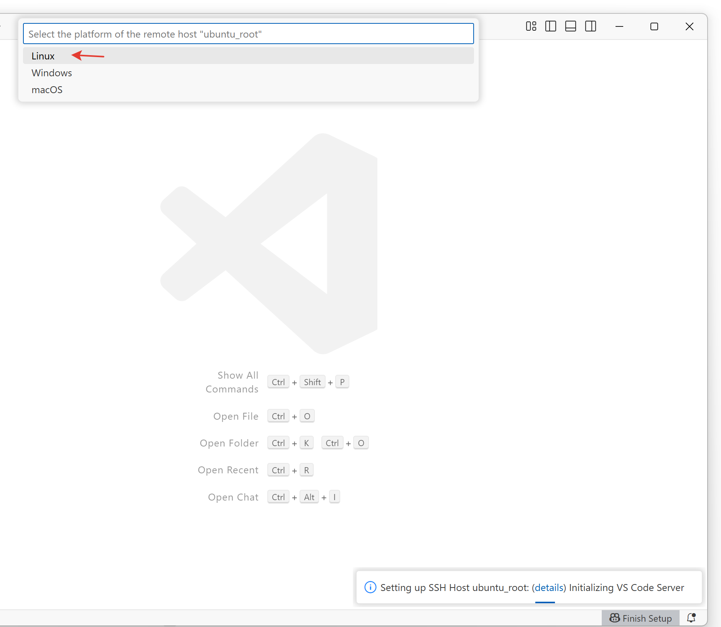
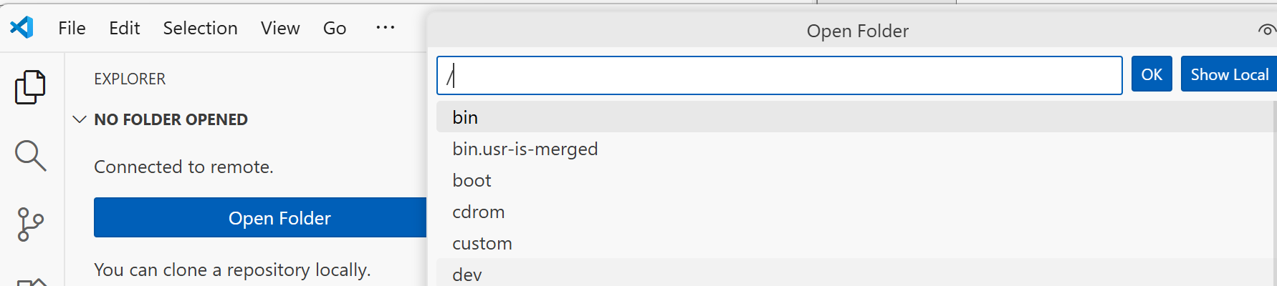
sudo visudo
admin ALL=(ALL) NOPASSWD: ALL
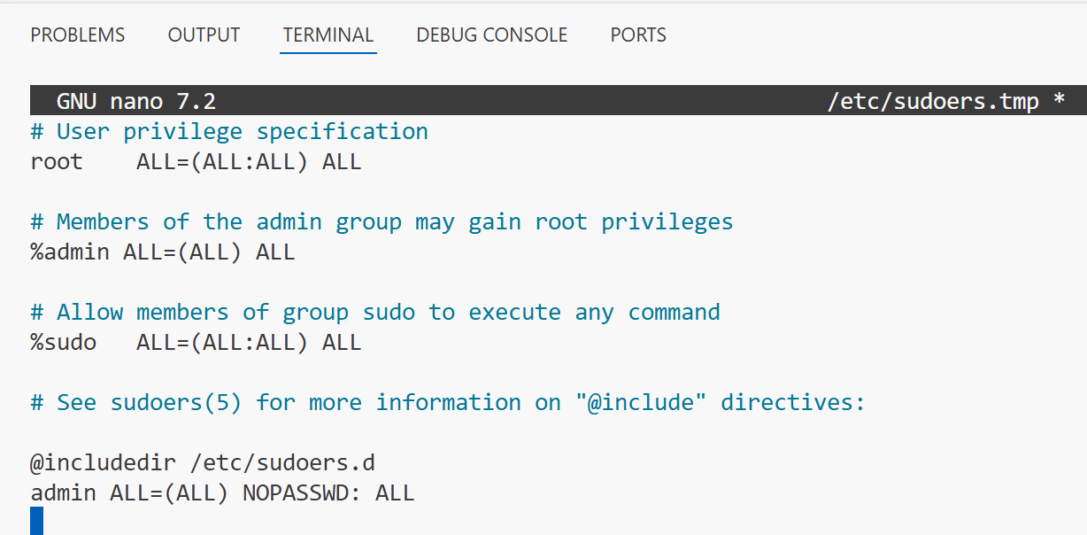
type $env:USERPROFILE\.ssh\id_ed25519.pub
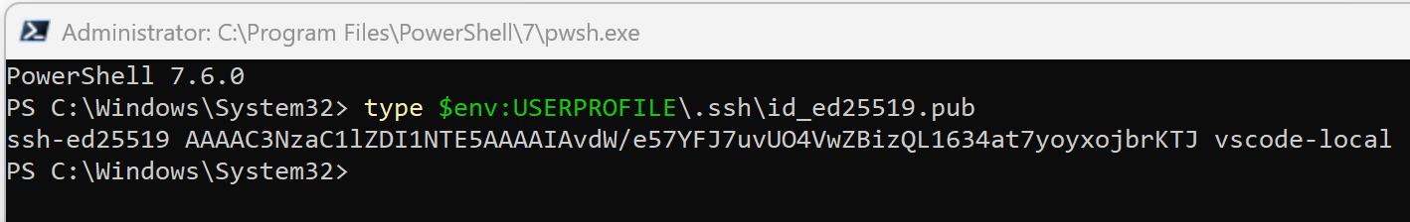
sudo mkdir -p /root/.ssh
sudo nano /root/.ssh/authorized_keys
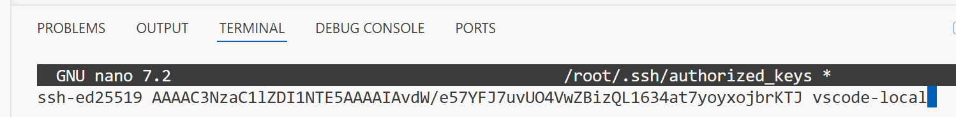
sudo chmod 700 /root/.ssh
sudo chmod 600 /root/.ssh/authorized_keys
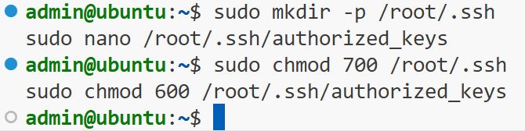
sudo nano /etc/ssh/sshd_config

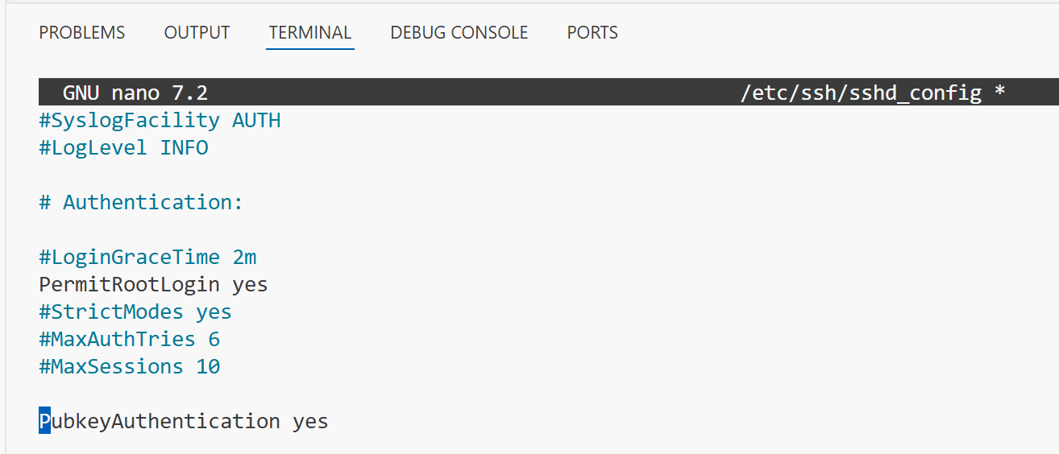
sudo systemctl restart ssh
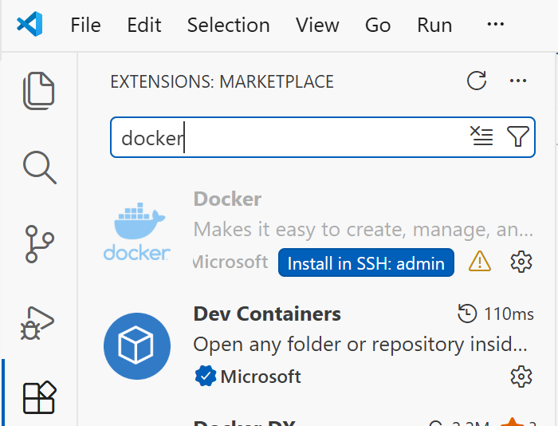
sudo groupadd docker
sudo usermod -aG docker admin
перезапустить виртуалку
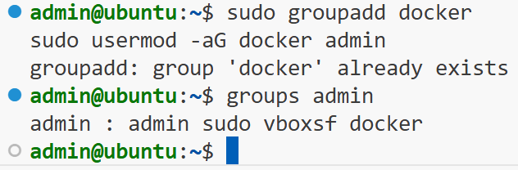

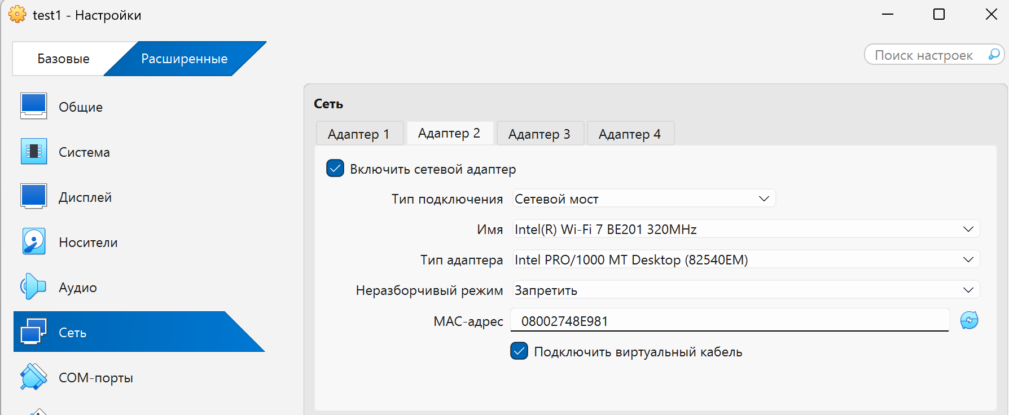
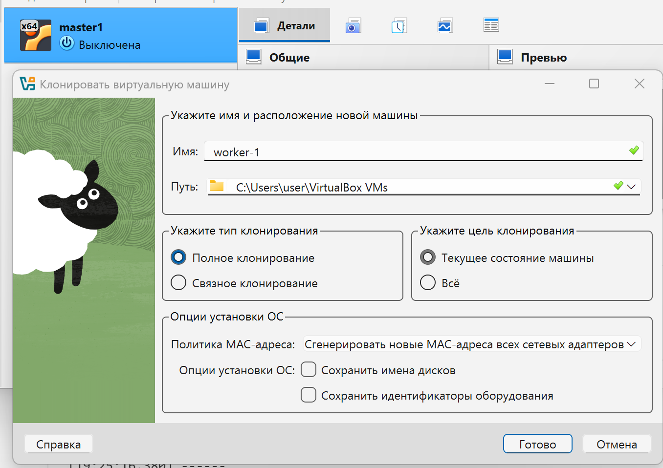

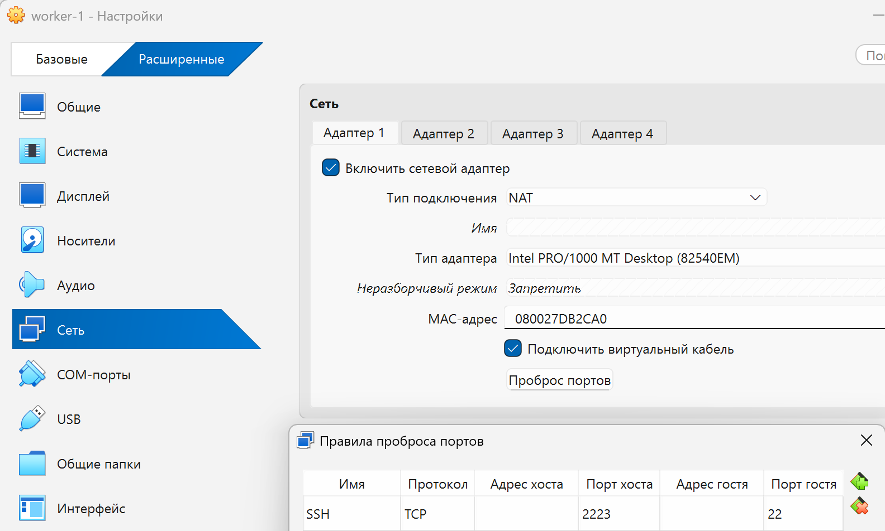
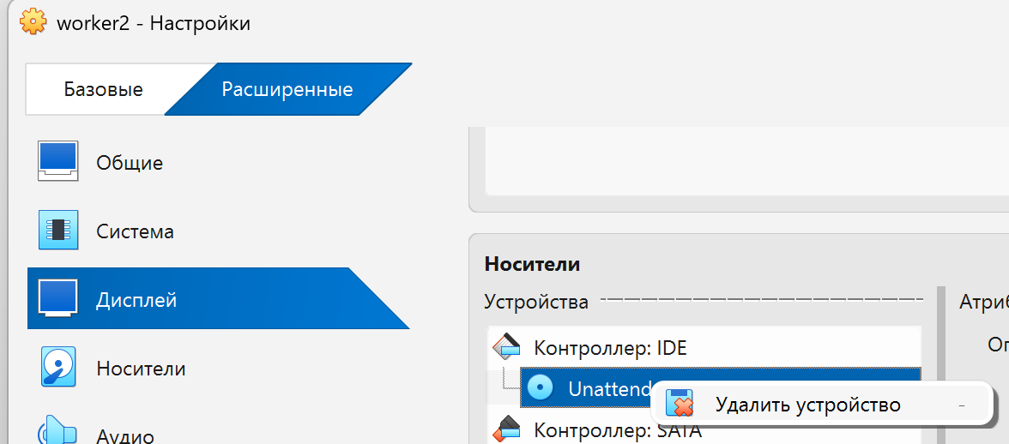

Ipconfig
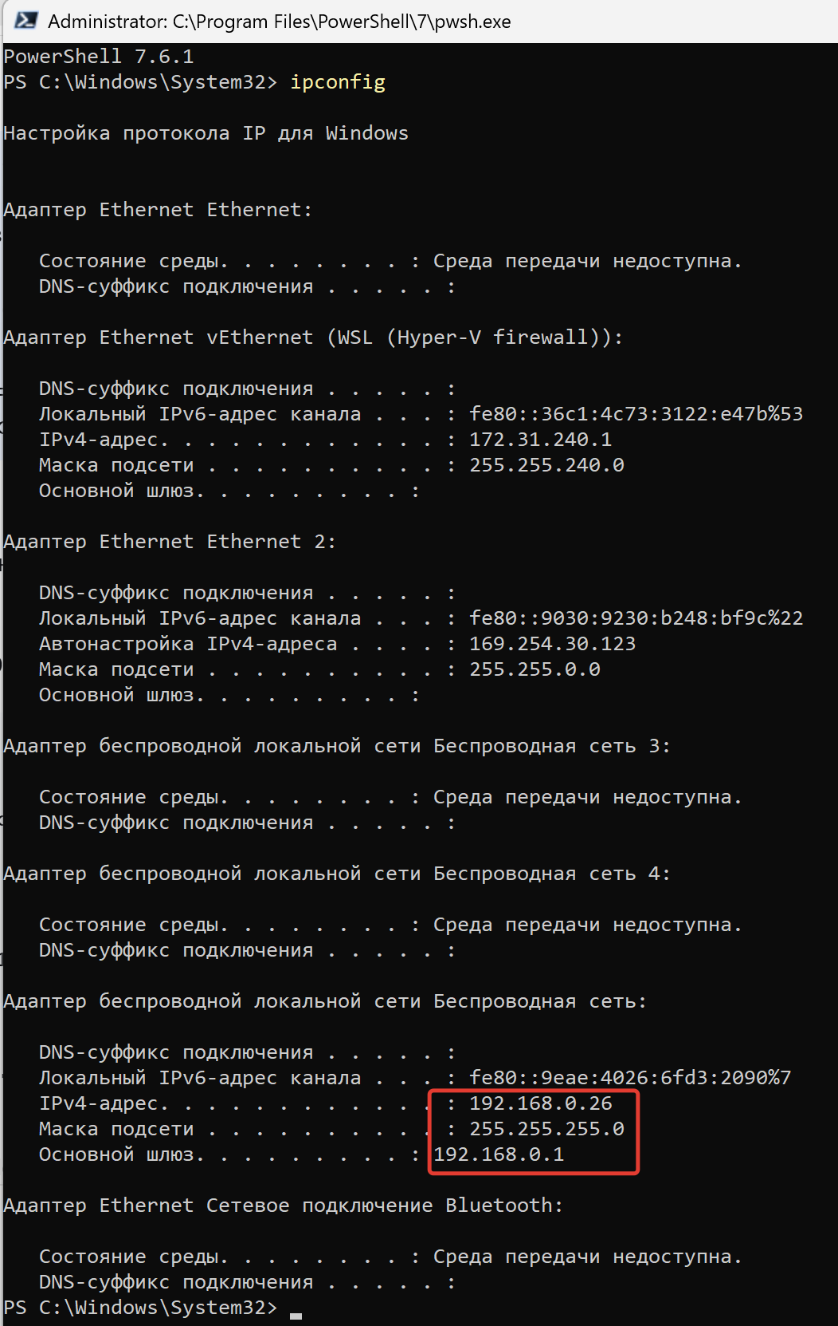
Маска подсети | CIDR | Биты | Количество хостов
255.0.0.0 | /8 | 8 | 16 777 214
255.128.0.0 | /9 | 9 | 8 388 606
255.192.0.0 | /10 | 10 | 4 194 302
255.224.0.0 | /11 | 11 | 2 097 150
255.240.0.0 | /12 | 12 | 1 048 574
255.248.0.0 | /13 | 13 | 524 286
255.252.0.0 | /14 | 14 | 262 142
255.254.0.0 | /15 | 15 | 131 070
255.255.0.0 | /16 | 16 | 65 534
255.255.128.0 | /17 | 17 | 32 766
255.255.192.0 | /18 | 18 | 16 382
255.255.224.0 | /19 | 19 | 8 190
255.255.240.0 | /20 | 20 | 4 094
255.255.248.0 | /21 | 21 | 2 046
255.255.252.0 | /22 | 22 | 1 022
255.255.254.0 | /23 | 23 | 510
255.255.255.0 | /24 | 24 | 254
255.255.255.128 | /25 | 25 | 126
255.255.255.192 | /26 | 26 | 62
255.255.255.224 | /27 | 27 | 30
255.255.255.240 | /28 | 28 | 14
255.255.255.248 | /29 | 29 | 6
255.255.255.252 | /30 | 30 | 2
255.255.255.254 | /31 | 31 | 2 (точка-точка)
255.255.255.255 | /32 | 32 | 1 (конкретный хост)

ip a

# ===== Мастер-нода 1 =====
Host master1
HostName 192.168.0.33
User admin
Port 22
ServerAliveInterval 60
ServerAliveCountMax 3

Host master1-admin
HostName localhost
User admin
Port 2222

Host master1-root
HostName localhost
User root
Port 2222

# ===== Мастер-нода 2 =====
Host master2
HostName 192.168.0.36
User admin
Port 22
ServerAliveInterval 60
ServerAliveCountMax 3

Host master2-admin
HostName localhost
User admin
Port 2223

Host master2-root
HostName localhost
User root
Port 2223

# ===== Мастер-нода 3 =====
Host master3
HostName 192.168.0.37
User admin
Port 22
ServerAliveInterval 60
ServerAliveCountMax 3

Host master3-admin
HostName localhost
User admin
Port 2224

Host master3-root
HostName localhost
User root
Port 2224

# ===== Воркер-нода 1 =====
Host worker1
HostName 192.168.0.34
User admin
Port 22
ServerAliveInterval 60
ServerAliveCountMax 3

Host worker1-admin
HostName localhost
User admin
Port 2225

Host worker1-root
HostName localhost
User root
Port 2225

# ===== Воркер-нода 2 =====
Host worker2
HostName 192.168.0.35
User admin
Port 22
ServerAliveInterval 60
ServerAliveCountMax 3

Host worker2-admin
HostName localhost
User admin
Port 2226

Host worker2-root
HostName localhost
User root
Port 2226

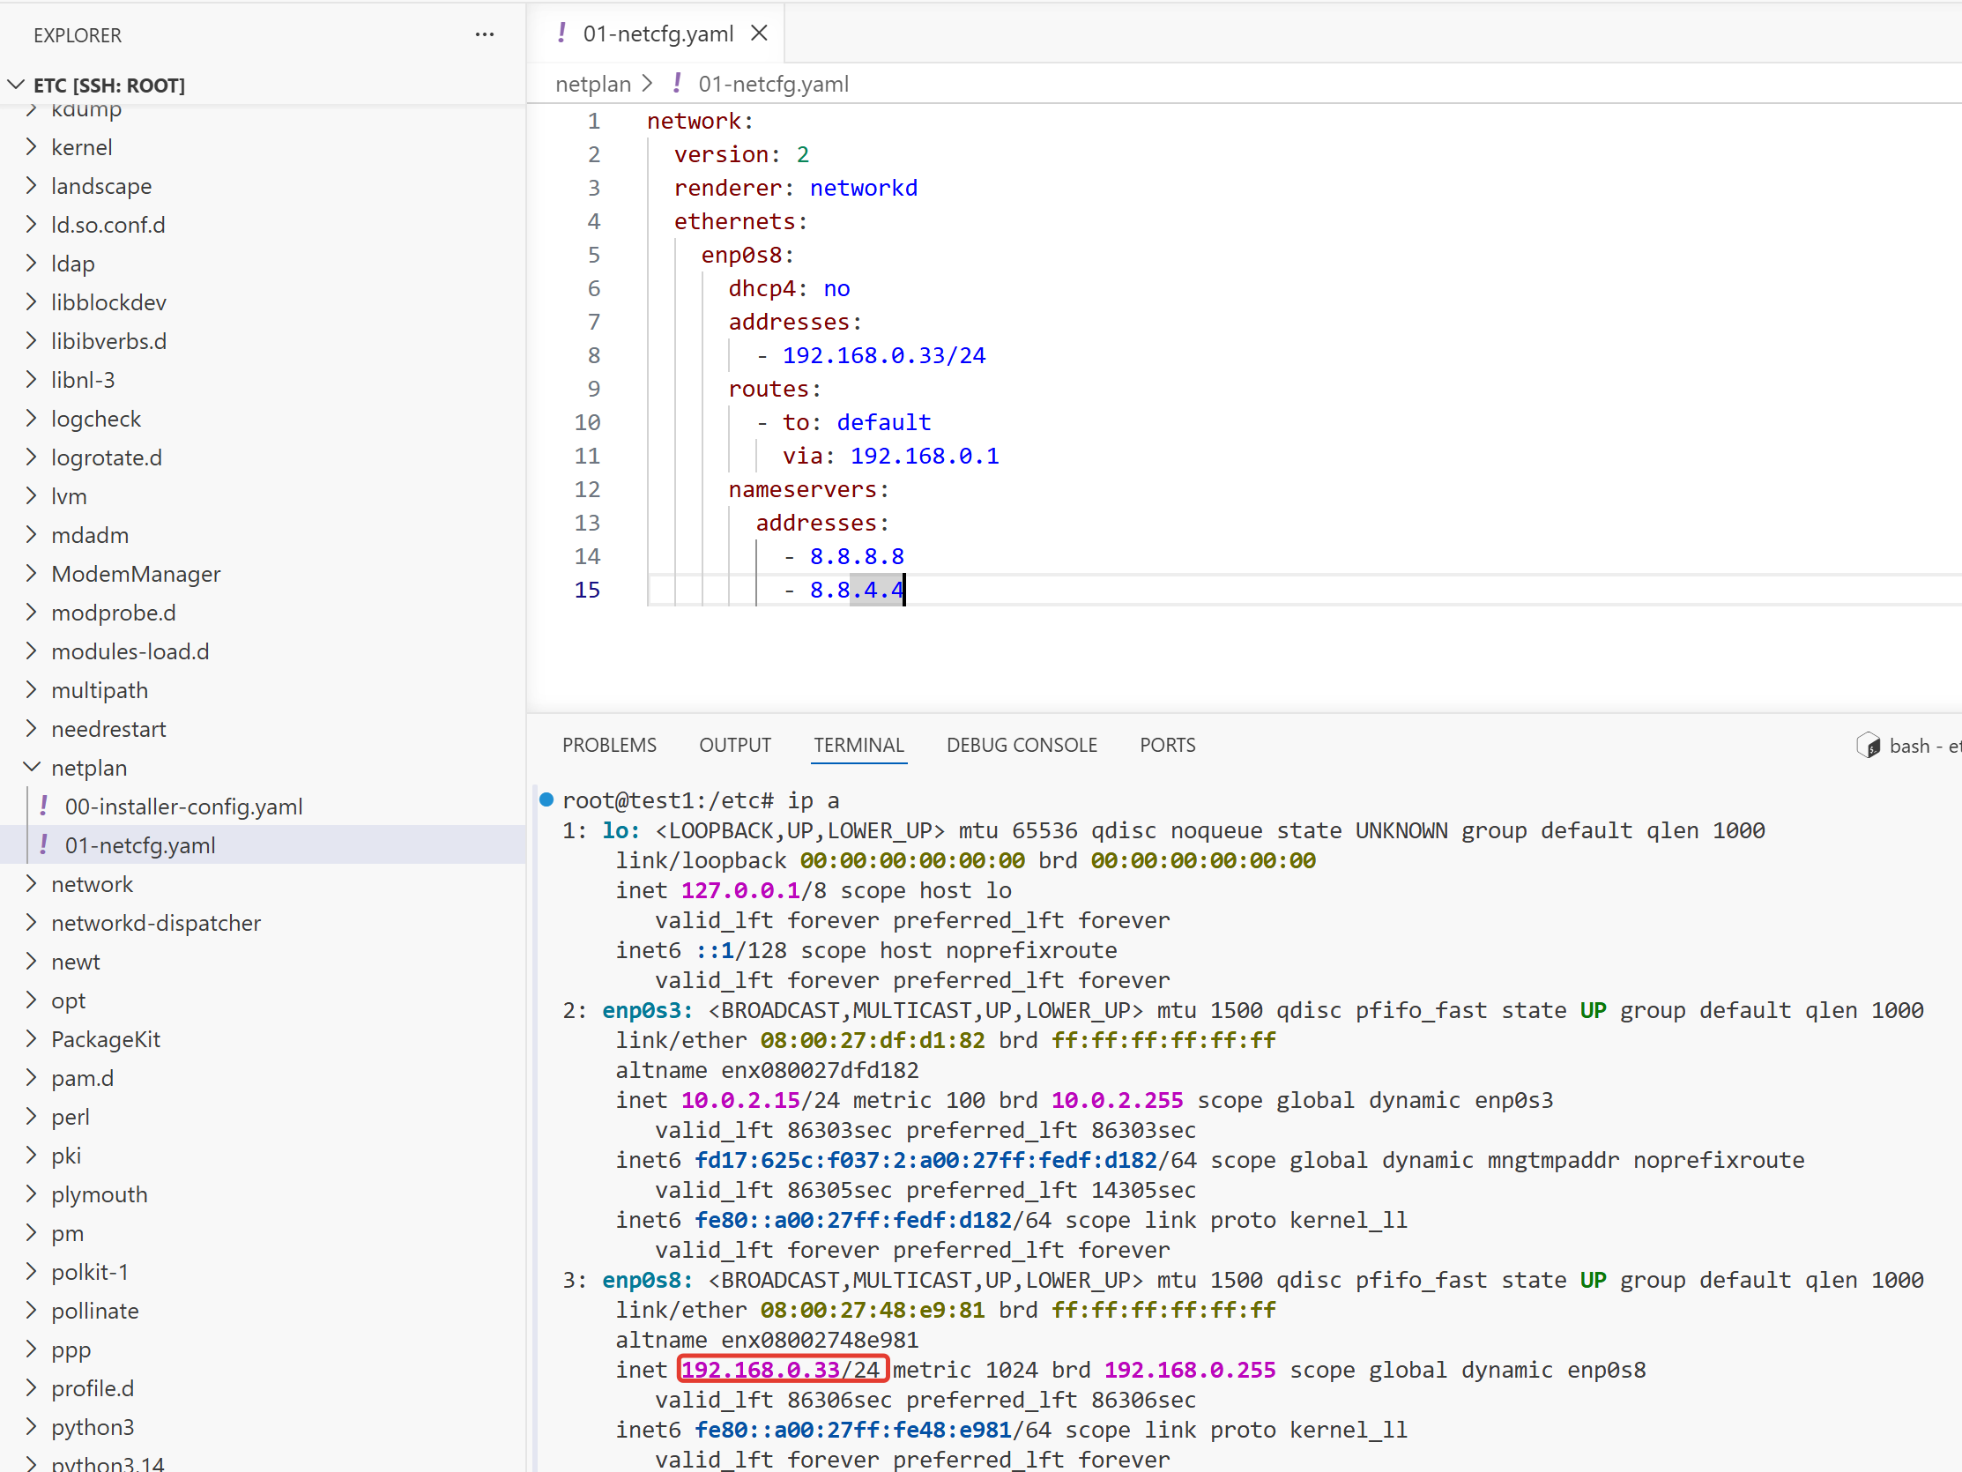
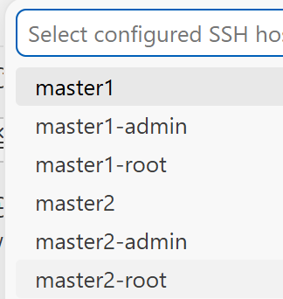

master1 (/etc/netplan/01-netcfg.yaml)
network:
version: 2
renderer: networkd
ethernets:
enp0s3:
dhcp4: true
enp0s8:
dhcp4: no
addresses:
- 192.168.0.33/24
routes:
- to: default
via: 192.168.0.1
nameservers:
addresses:
- 8.8.8.8
- 8.8.4.4

master2 (/etc/netplan/01-netcfg.yaml)
network:
version: 2
renderer: networkd
ethernets:
enp0s3:
dhcp4: true
enp0s8:
dhcp4: no
addresses:
- 192.168.0.34/24
routes:
- to: default
via: 192.168.0.1
nameservers:
addresses:
- 8.8.8.8
- 8.8.4.4

master3 (/etc/netplan/01-netcfg.yaml)
network:
version: 2
renderer: networkd
ethernets:
enp0s3:
dhcp4: true
enp0s8:
dhcp4: no
addresses:
- 192.168.0.35/24
routes:
- to: default
via: 192.168.0.1
nameservers:
addresses:
- 8.8.8.8
- 8.8.4.4

worker1 (/etc/netplan/01-netcfg.yaml)
network:
version: 2
renderer: networkd
ethernets:
enp0s3:
dhcp4: true
enp0s8:
dhcp4: no
addresses:
- 192.168.0.36/24
routes:
- to: default
via: 192.168.0.1
nameservers:
addresses:
- 8.8.8.8
- 8.8.4.4

worker2 (/etc/netplan/01-netcfg.yaml)
network:
version: 2
renderer: networkd
ethernets:
enp0s3:
dhcp4: true
enp0s8:
dhcp4: no
addresses:
- 192.168.0.37/24
routes:
- to: default
via: 192.168.0.1
nameservers:
addresses:
- 8.8.8.8
- 8.8.4.4

sudo rm -f /etc/netplan/00-installer-config.yaml
sudo chmod 600 /etc/netplan/01-netcfg.yaml
sudo netplan apply

sudo hostnamectl set-hostname master1
sudo hostnamectl set-hostname master2
sudo hostnamectl set-hostname master3
sudo hostnamectl set-hostname worker1
sudo hostnamectl set-hostname worker2

